***Footwear sales forecasting***

***ACKNOWLEDGEMENT***

We would like to express our heartfelt gratitude to **Lokesh Malviya Sir**, for his invaluable guidance and unwavering supervision throughout my journey. His mentorship has been instrumental in shaping our growth and development. Sir consistently reviewed our work, providing constructive feedback that significantly improved the quality of our efforts. We feel truly fortunate to have had the opportunity to work under him.

**Signature**

**KESHAV MALHOTRA (219310049),**

**HS DHOOP (219310328),**

**AIML 5D**

**MANIPAL UNIVERSITY JAIPUR**

Index

|  |  |  |
| --- | --- | --- |
| **S.No.** | **Activity Heads** | **Page no.** |
|  | Abstract | 1 |
|  | Introduction | 1 |
|  | Brief Description | 2 |
|  | Technique/Method | 2 |
|  | Results and analysis | 3 |
|  | Conclusion and Future Scope | 3 |
|  | References | 4 |

1. **Abstract**

This project aims to perform time series forecasting for footwear demand in five Middle Eastern countries: the United Arab Emirates (UAE), Saudi Arabia, Egypt, Oman, and Qatar. The footwear industry is dynamic and influenced by various factors, including economic conditions, cultural trends, and seasonal variations. Accurate demand forecasting is essential for manufacturers, retailers, and supply chain management to optimize inventory, production, and distribution.

To achieve this, the project utilizes historical sales data and incorporates various time series forecasting techniques using Prophet, to model and predict footwear demand for each country separately. These methods consider seasonality, trends, and historical patterns, providing insights into the future demand for footwear products.

Furthermore, the project considers external variables, such as economic indicators, cultural events, and holidays, that might impact footwear demand. By incorporating these factors into the forecasting models, we aim to enhance the accuracy and robustness of the predictions.

1. **Introduction**

The footwear industry in the Middle East is a dynamic and multifaceted sector, influenced by a plethora of factors, including economic conditions, cultural trends, and seasonality. As a result, accurate and data-driven forecasting is imperative for stakeholders in this industry, ranging from manufacturers and retailers to supply chain managers. This project embarks on a journey to leverage the power of time series forecasting and data analysis to gain deeper insights into footwear demand across five key Middle Eastern countries: the United Arab Emirates (UAE), Saudi Arabia, Egypt, Oman, Kuwait, Qatar.

Time series forecasting, a crucial tool in predictive analytics, is the practice of utilizing historical data to make future predictions. In the context of the footwear industry, this involves using past sales data, patterns, and trends to project future consumer demand. This approach allows businesses to anticipate fluctuations in demand, plan their production cycles, optimize inventory, and fine-tune marketing strategies.

1. **Brief Description**

This project focuses on the application of time series forecasting and data analysis to gain insights into the demand for footwear in five key Middle Eastern countries: the United Arab Emirates (UAE), Saudi Arabia, Egypt, Oman, and Qatar. The footwear industry is subject to a range of dynamic factors, from economic conditions to cultural trends, making accurate demand forecasting crucial for businesses in the sector.

The insights derived from this project will offer valuable information for businesses operating in the Middle Eastern footwear market. These insights can help them optimize inventory management, production, and marketing strategies. The ultimate goal is to enable companies to better meet consumer needs, mitigate stockouts or overstock situations, and achieve cost savings while enhancing customer satisfaction.

1. **Technique/Method used**

**This project utilizes a combination of time series forecasting methods**

* **Prophet: Prophet is a specialized forecasting tool designed to handle time series data with strong seasonality and holidays. It is particularly adept at capturing irregular patterns and abrupt changes, making it a valuable addition to the forecasting toolkit.**
* **Data Preprocessing: Before applying forecasting models, data preprocessing is essential. This includes tasks such as cleaning and transforming data, handling missing values, and ensuring data is in a suitable format for analysis.**
* **Country-Specific Analysis: Recognizing that each of the five Middle Eastern countries has its unique characteristics and trends, the project customizes the forecasting models and data analysis for each country. This tailored approach ensures that the insights and predictions are relevant to the specific market dynamics of each nation.**
* **Visualization: Data visualization techniques, such as time series plots, trend decomposition, and seasonality analysis, are used to present the results and make them more accessible to stakeholders.**

1. **Results and analysis**

The project's results offer businesses in the Middle East's footwear industry highly accurate and country-specific forecasts, enabling them to optimize inventory management and meet consumer demands effectively. By combining advanced time series forecasting techniques with data analysis, this project empowers businesses to navigate the dynamic market and make informed decisions.

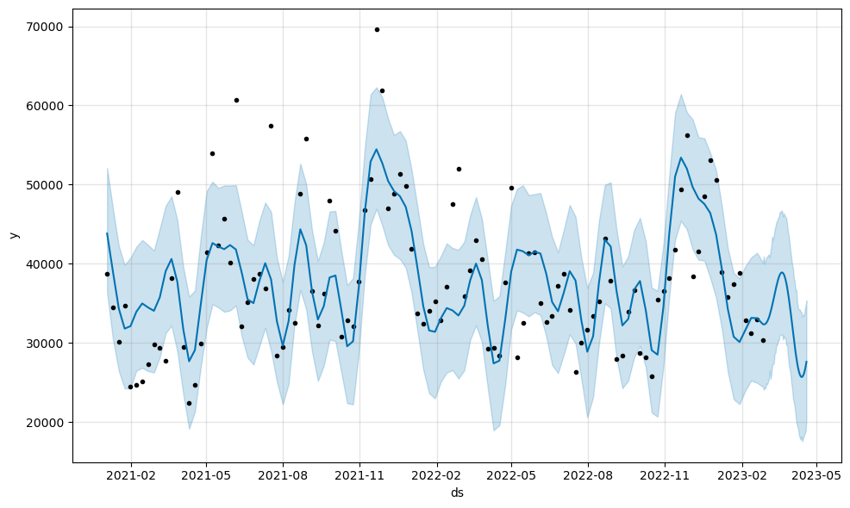

Fig 1 –UAE

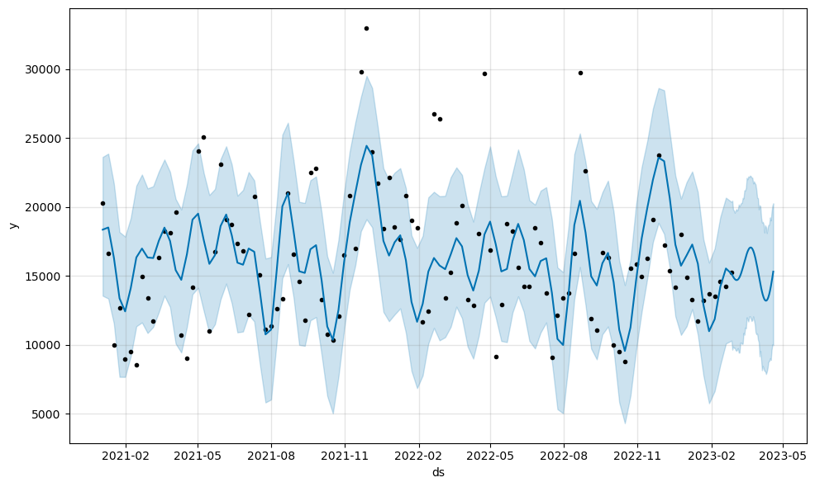

Fig 2- Saudi Arabia

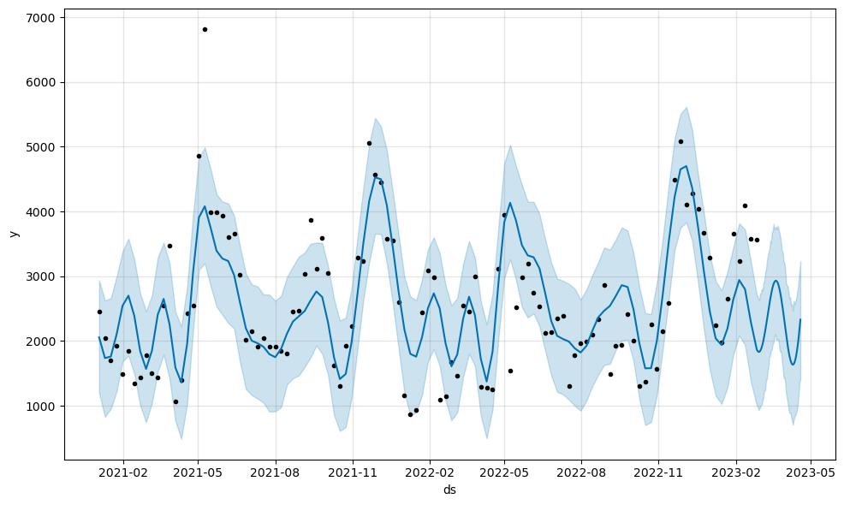

Fig 3 – Qatar

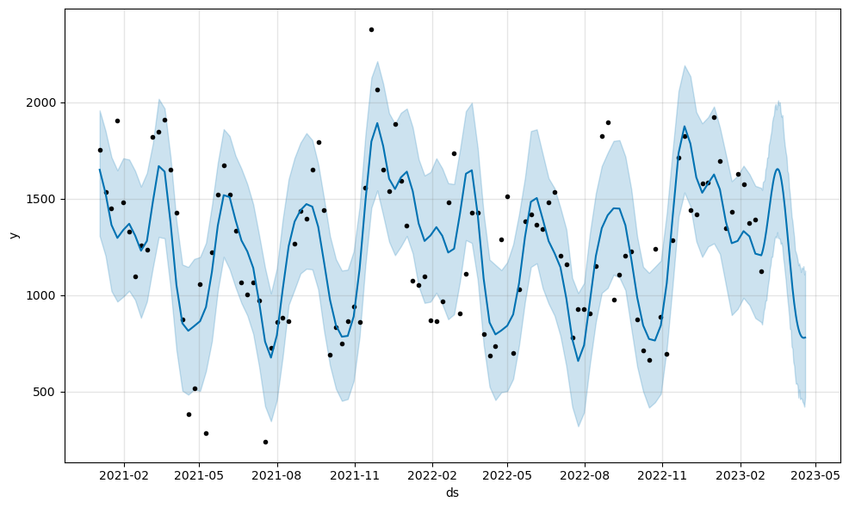

Fig 4 – Kuwait

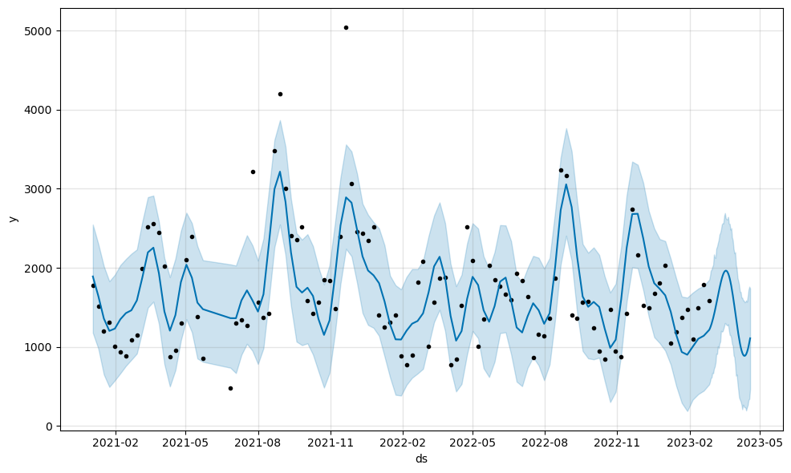

Fig 5 – Egypt

### Conclusion

We came to the conclusion that festival or shopping vents plays a vital role in footwear sales. We have plotted the major festivals and events of each country separately. Festivals like EID – AL -ADHA and RAMADAN shows sales rise.

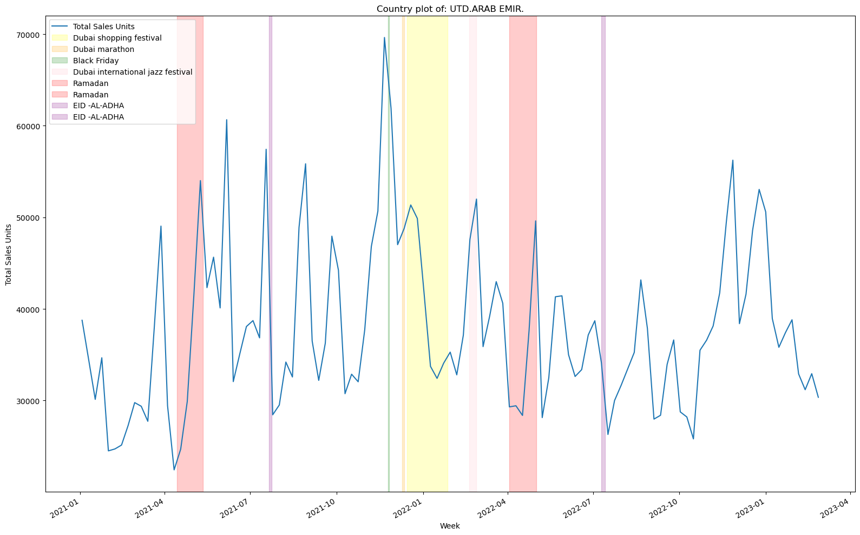

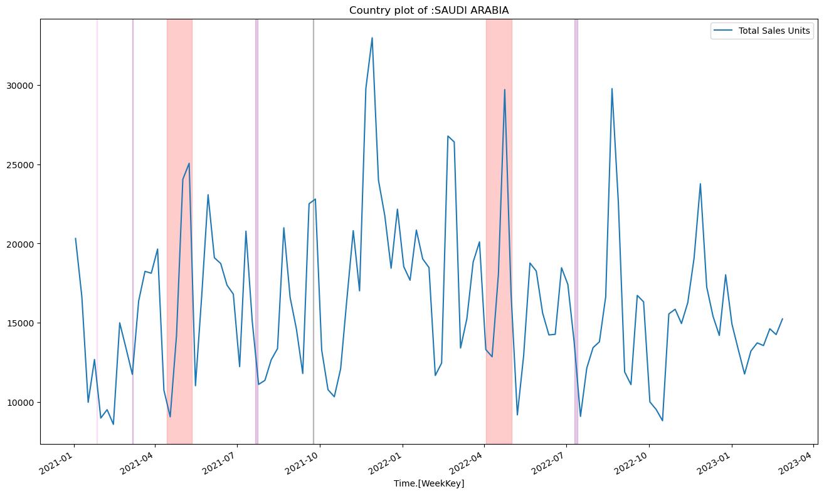

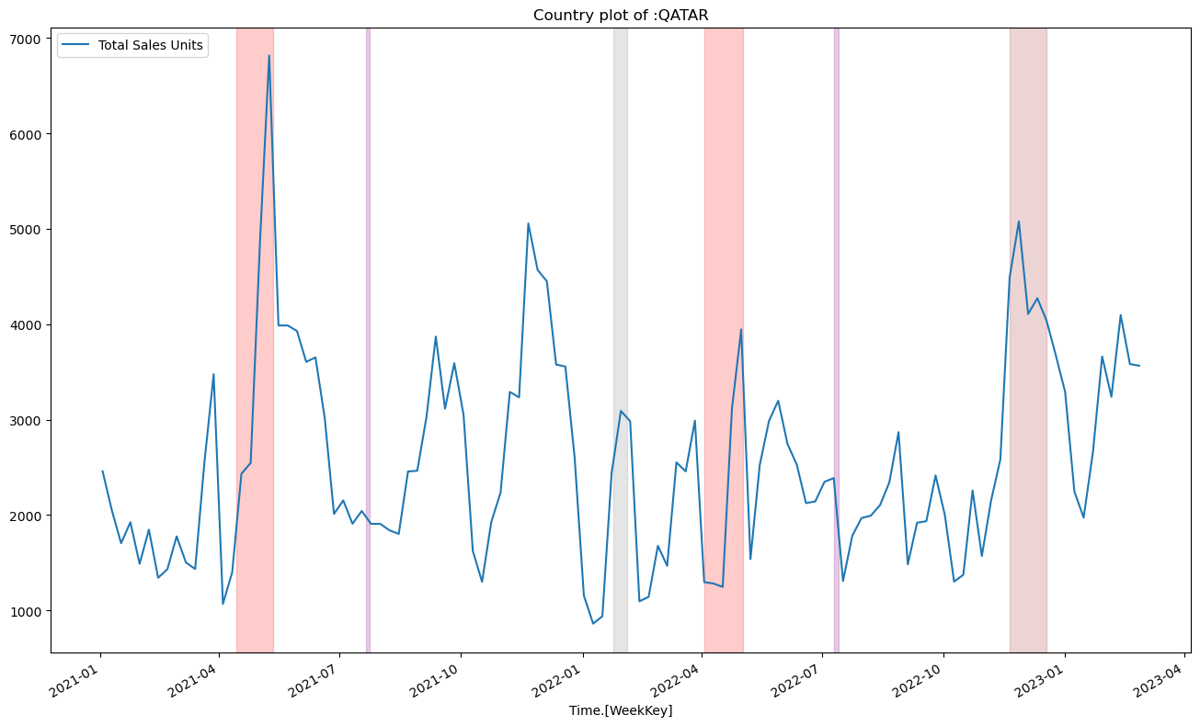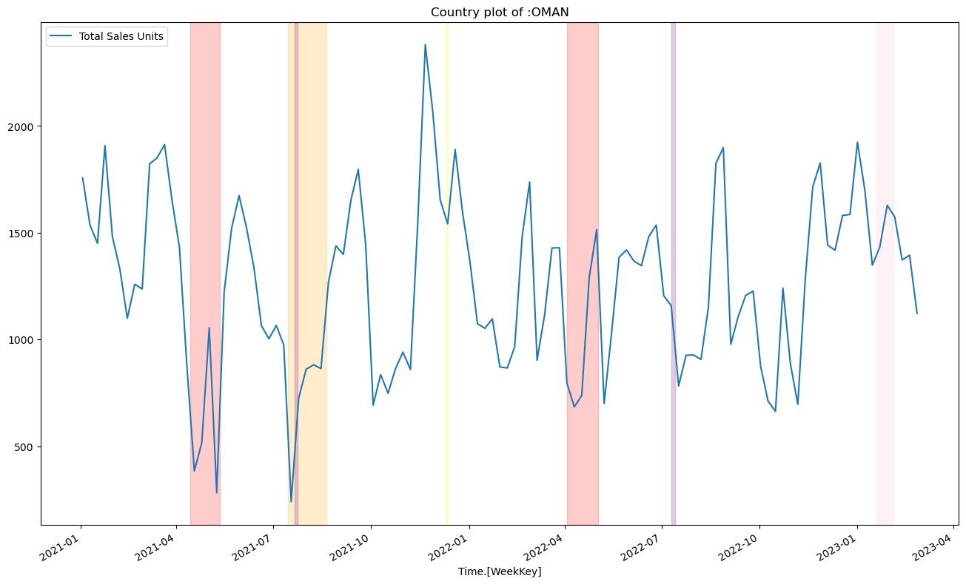

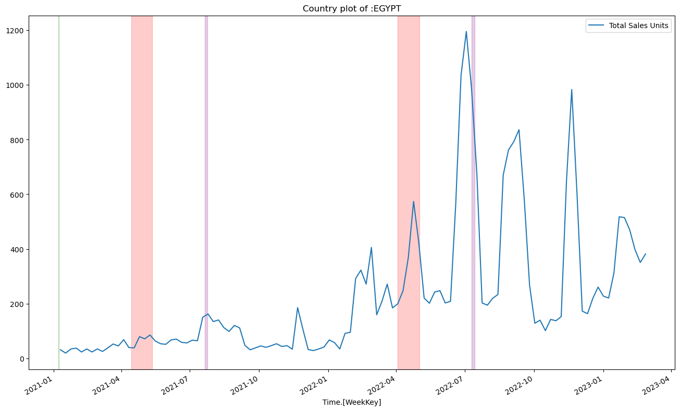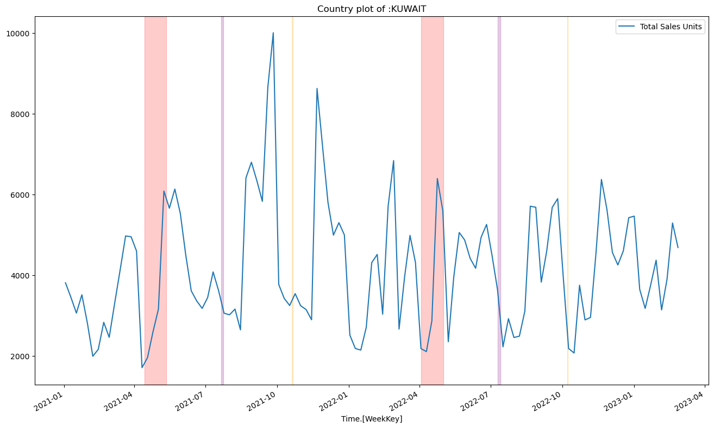

## ***7.References***

1. Wu, Yuankai, et al. "A hybrid deep learning based traffic flow prediction method and its understanding." Transportation Research Part C: Emerging Technologies 90 (2018): 166-180..

2. Wu, Yuankai, et al. "A hybrid deep learning based traffic flow prediction method and its understanding." Transportation Research Part C: Emerging Technologies 90 (2018): 166-180.

3. Miglani, Arzoo, and Neeraj Kumar. "Deep learning models for traffic flow prediction in autonomous vehicles: A review, solutions, and challenges." Vehicular Communications 20 (2019): 100184.

4. Mohammed, Hayder Riyadh Mohammed, and Sumarni Ismail. "Proposition of new computer artificial intelligence models for shear strength prediction of reinforced concrete beams." Engineering with Computers 38.4 (2022): 3739-3757.

5. Kashyap, Anirudh Ameya, et al. "Traffic flow prediction models–A review of deep learning techniques." Cogent Engineering 9.1 (2022): 2010510.

6. Nguyen, Hoang, et al. "Efficient machine learning models for prediction of concrete strengths." Construction and Building Materials 266 (2021): 120950.

7. Duan, Jin, et al. "A novel artificial intelligence technique to predict compressive strength of recycled aggregate concrete using ICA-XGBoost model." Engineering with Computers 37 (2021): 3329-3346.

8. Shariati M, Mafipour MS, Mehrabi P, Shariati A, Toghroli A, Trung NT, Salih MN. A novel approach to predict shear strength of tilted angle connectors using artificial intelligence techniques. Engineering with Computers. 2021 Jul;37(3):2089-109.

9. Mishra M, Bhatia AS, Maity D. Predicting the compressive strength of unreinforced brick masonry using machine learning techniques validated on a case study of a museum through nondestructive testing. Journal of Civil Structural Health Monitoring. 2020 Jul;10(3):389-403.

10. Feng, De-Cheng, et al. "Machine learning-based compressive strength prediction for concrete: An adaptive boosting approach." Construction and Building Materials 230 (2020): 117000.

11. Moayedi H, Hayati S. Artificial intelligence design charts for predicting friction capacity of driven pile in clay. Neural Computing and Applications. 2019 Nov;31(11):7429-4